# CS 255 System Design Document Template

## UML Diagrams

### UML Use Case Diagram

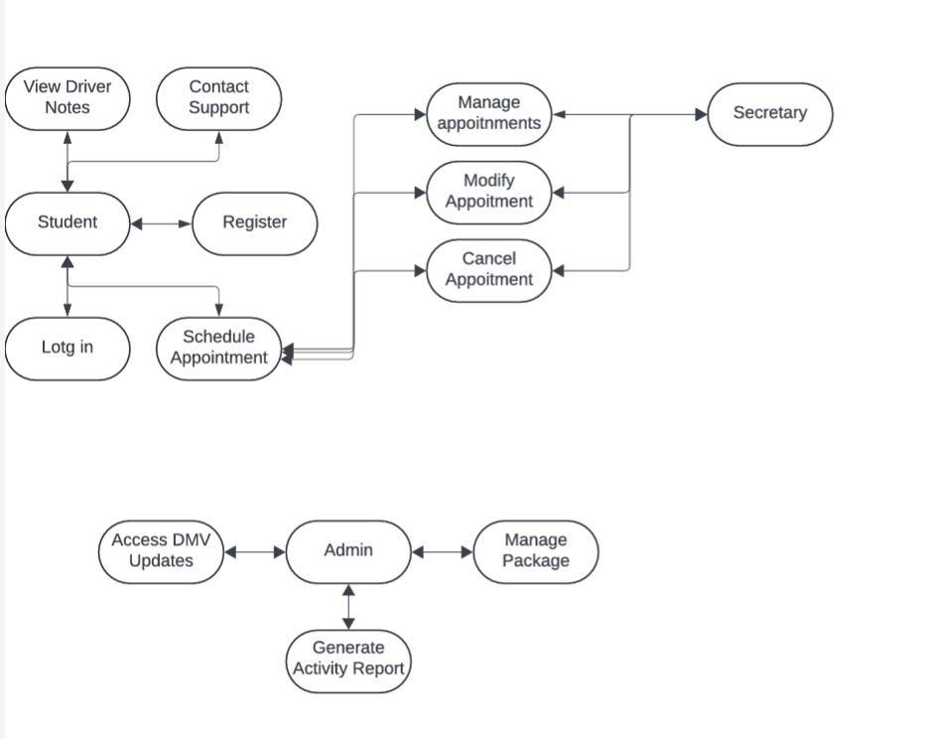

### UML Activity Diagrams

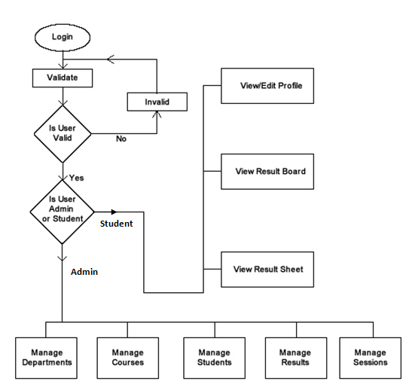

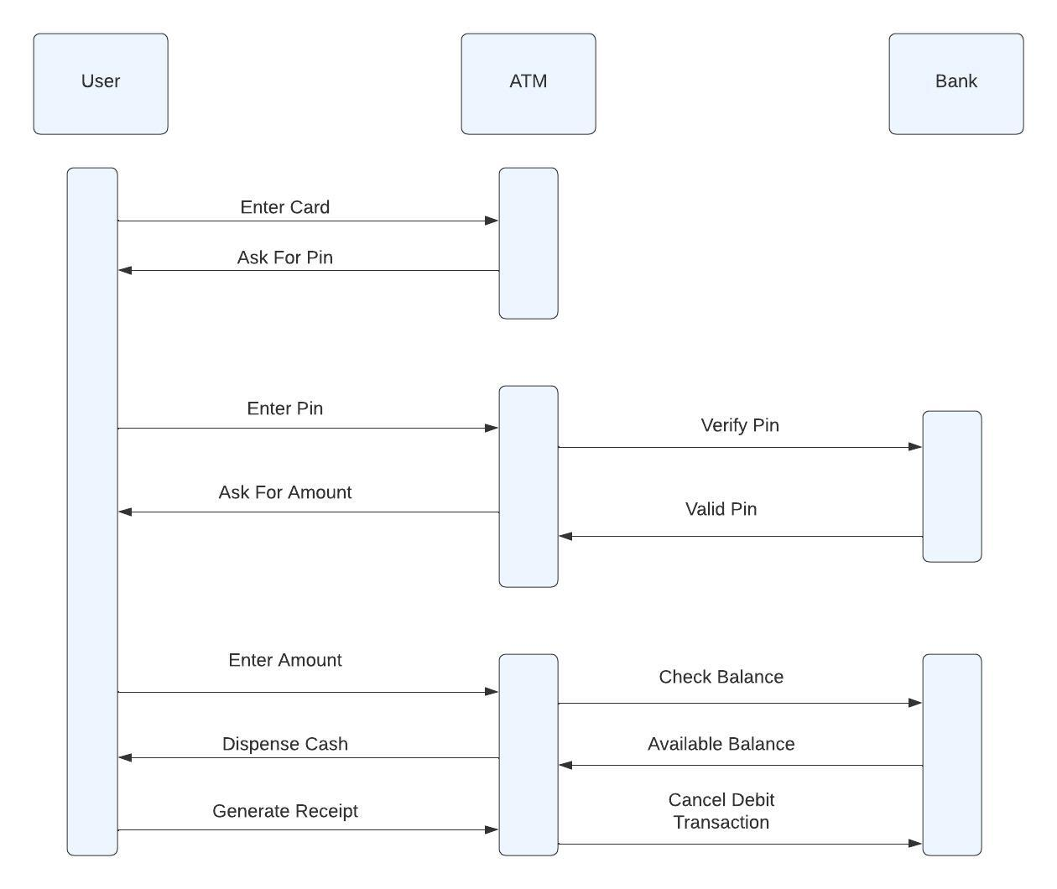

### UML Sequence Diagram

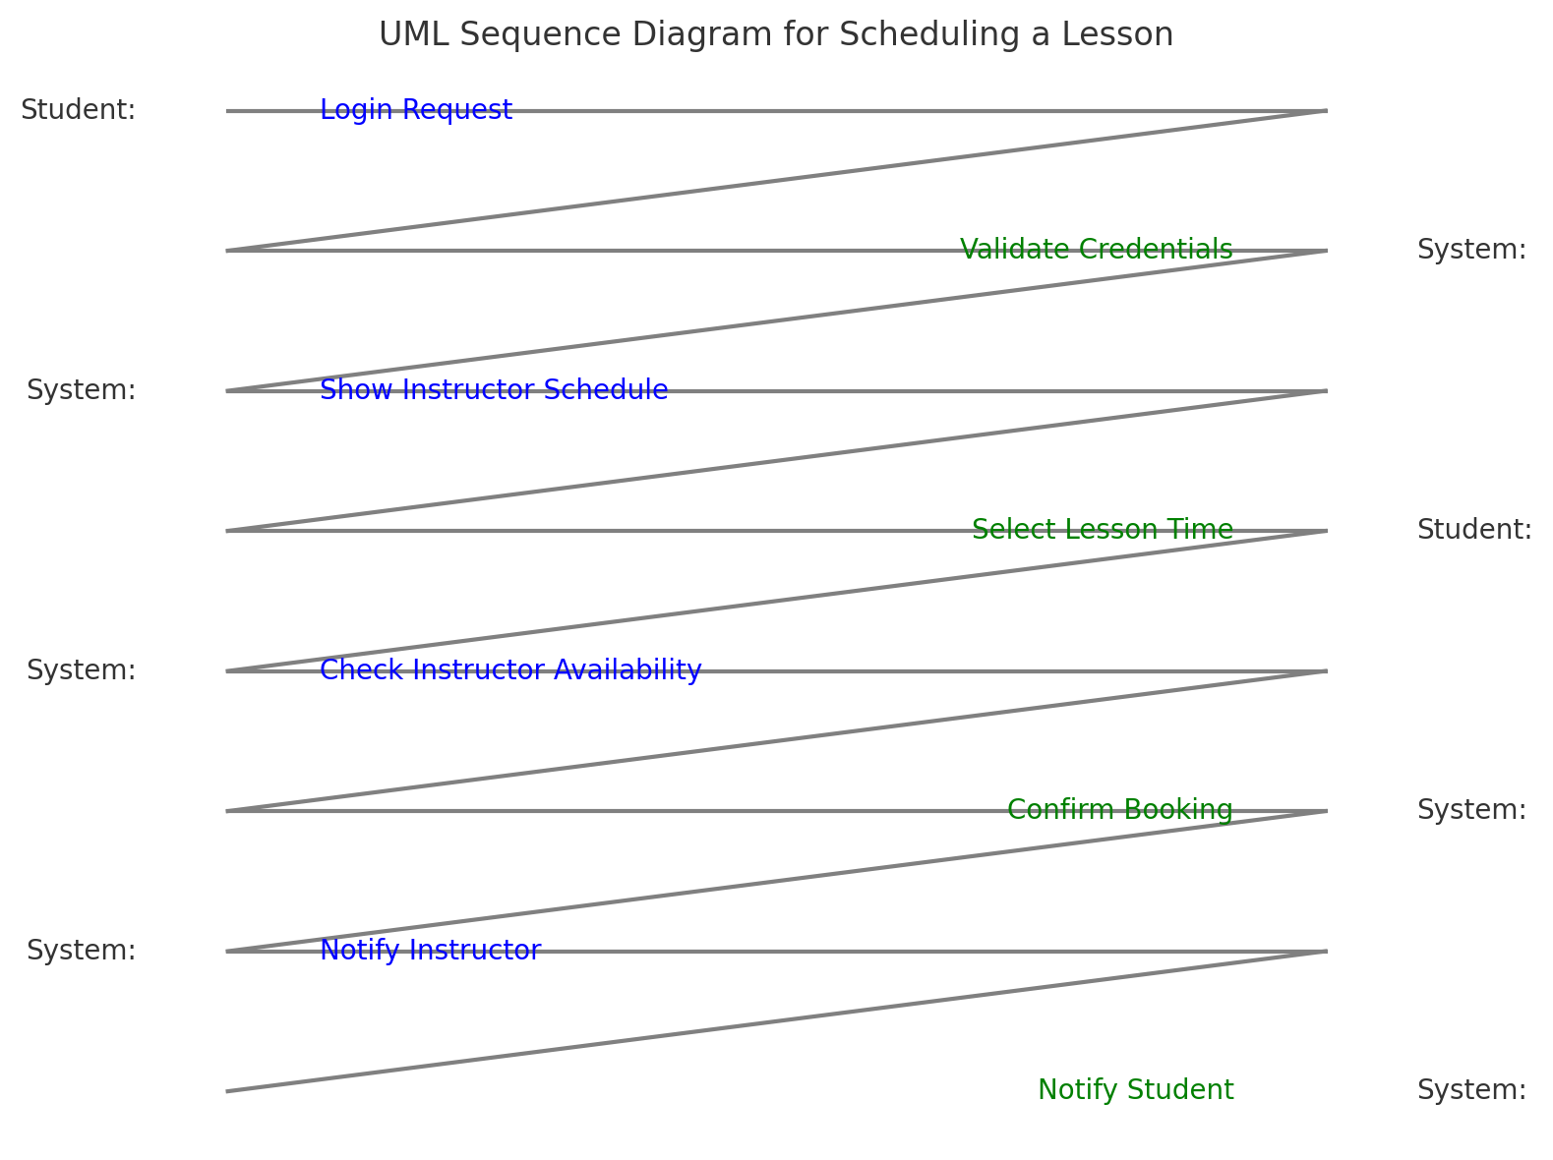

### UML Class Diagram

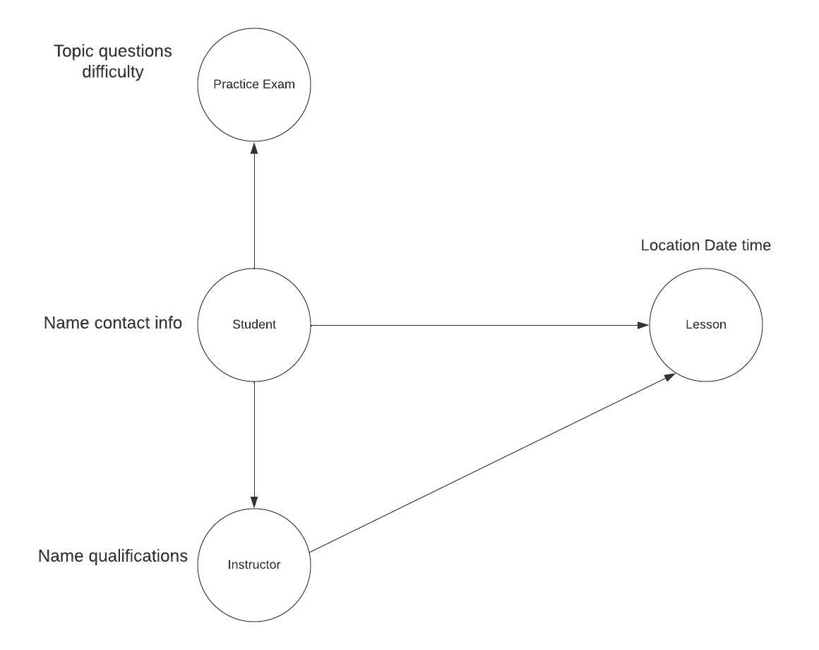

## Technical Requirements

* Hardware: Server capable of handling multiple user requests concurrently, with sufficient memory and storage for user data.
* Software: Web application framework (like Flask or Django), a database server, and front-end technologies such as HTML/CSS/JavaScript.
* Tools: CASE tools like Lucidchart for modeling, and Git for version control.